Implemented Strategy design pattern

**What it does:** Allows you to use different algorithms for the same function name (in this case, executeStrategy) and the algorithm will be different depending on the context given.

**How it was implemented:** Below is the screenshot of the code in use, and the code replaced commented out. They are functionally equivalent.

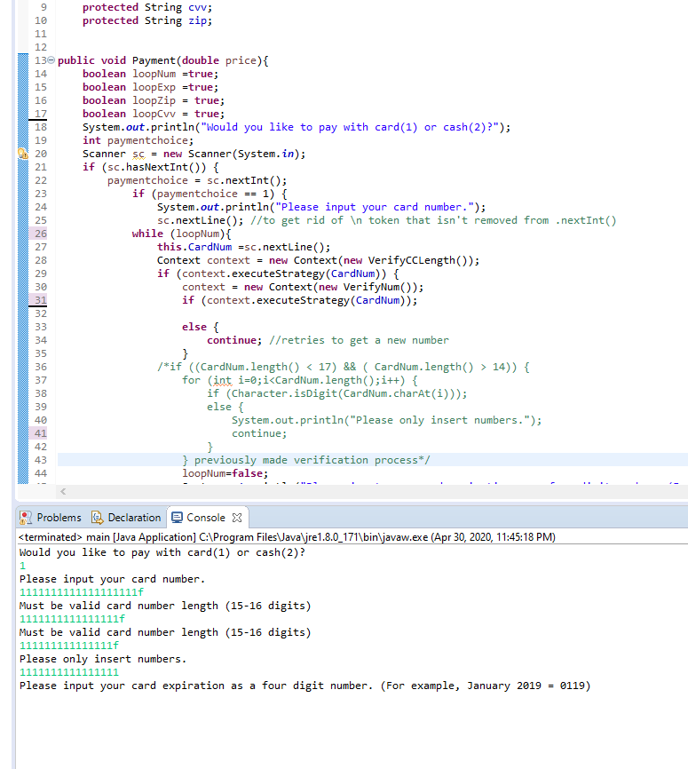

**Relevant Code Blocks**: The code blocks used to create this design pattern are shown below, and will also be included in the github.

